**Assignment 2**

**Problem Statement:** Create MFA for your AWS Account

**Solution:**

**MFA:** Multi-factor Authentication (MFA) is an authentication method that requires the user to provide two or more verification factors to gain access to a resource such as an application, online account, or a VPN. MFA is a core component of a strong **identity and access management (IAM)** policy. Rather than just asking for a username and password, MFA requires one or more additional verification factors, which decreases the likelihood of a successful cyber attack.

**Step 1:** At first open your **AWS Console** and click on your account, then select **Security Credentials**

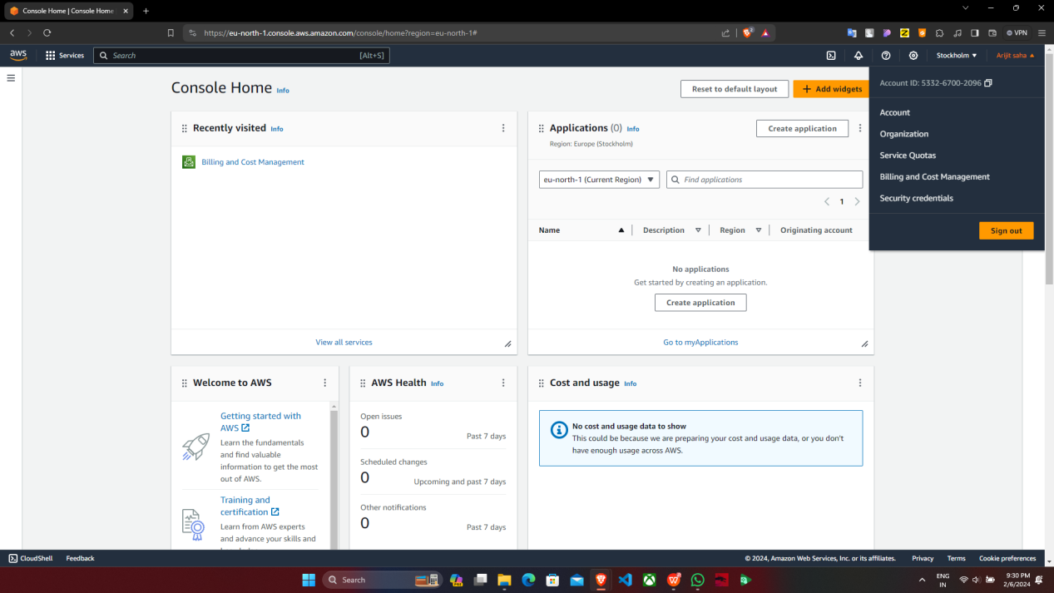

**Step 2:** Scroll down and you can find the **MFA** section. Click on **Assign MFA device** to add an MFA device

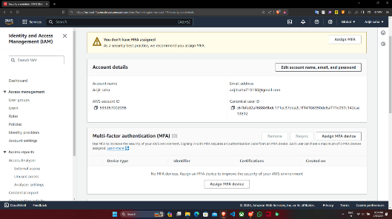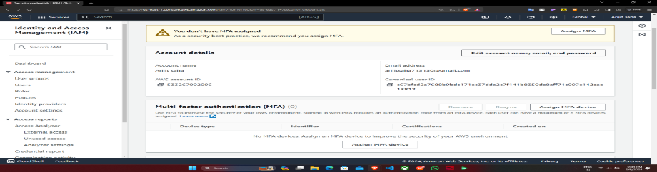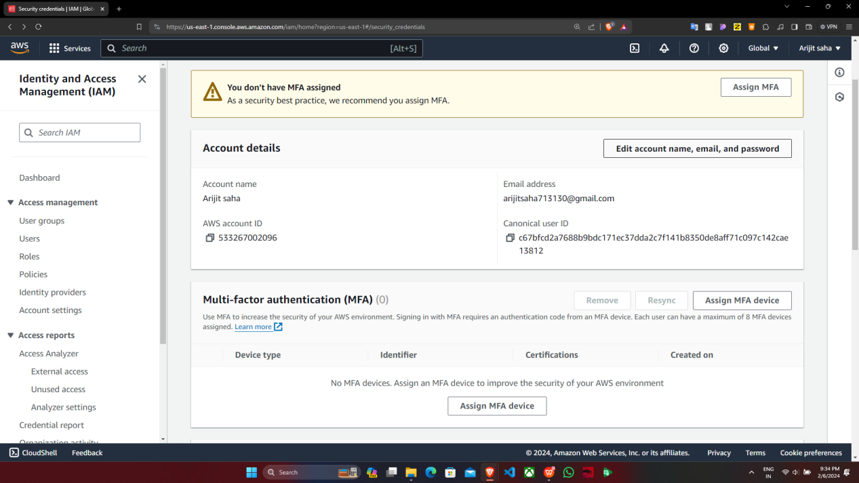

Supriyo Ghosh

Supriyoghosh27125@gmail.com



**Step 3:** Enter the **MFA device name, type of MFA device** and click on **Next**

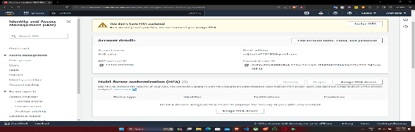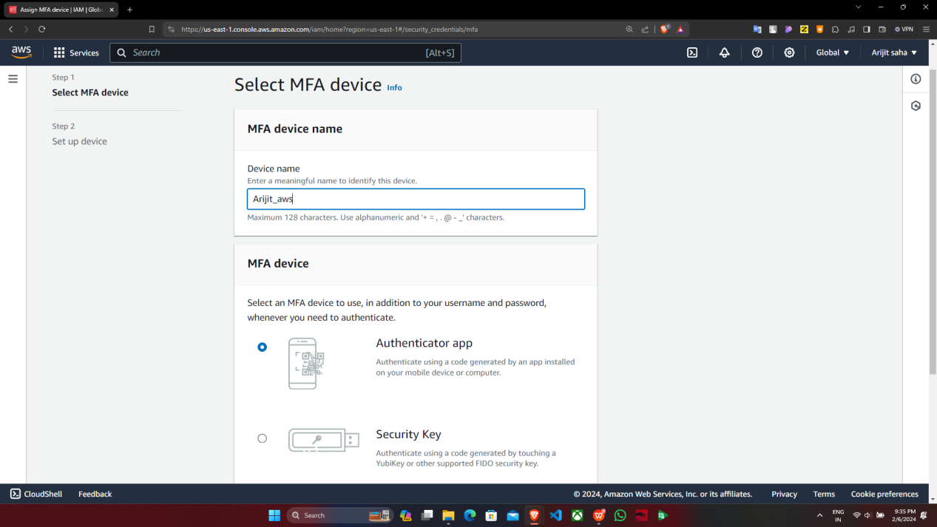

supriyo_aws

**Step 4: Download an MFA device** for example **Google Authenticator** on your **Android device** and scan the **QR code (for security purposes it is fake on the image).** You can find the **MFA codes generated in the app**, **enter two consecutive MFA codes,** and click on **Add MFA** to complete your MFA setup. You should find a dialog box showing that you have successfully completed the MFA setup

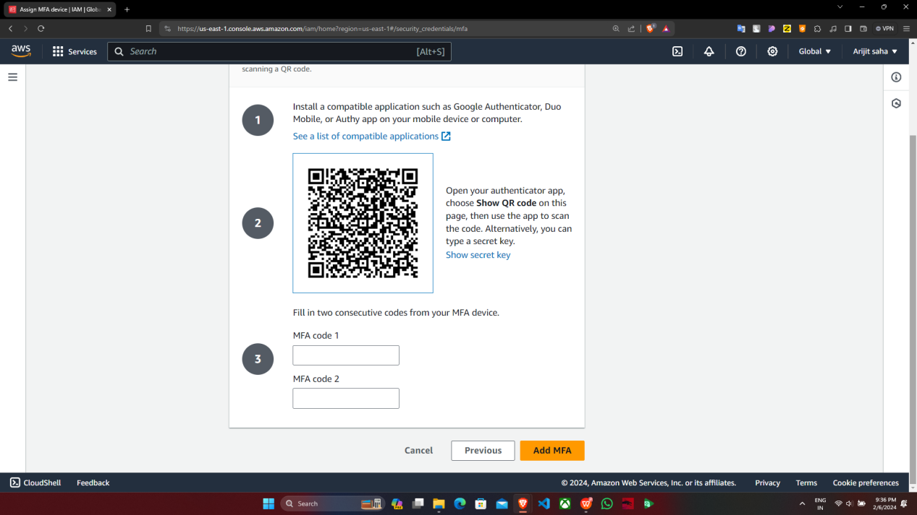

**Step 5:** Finally **MFA** is assign for your AWS account

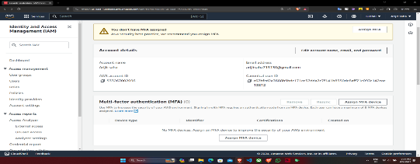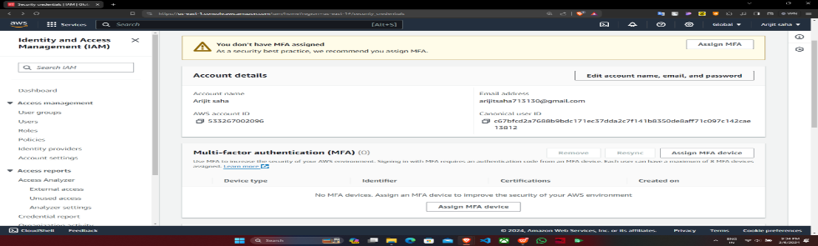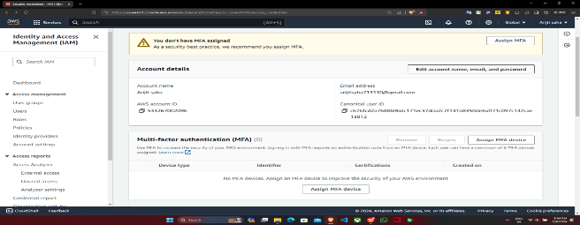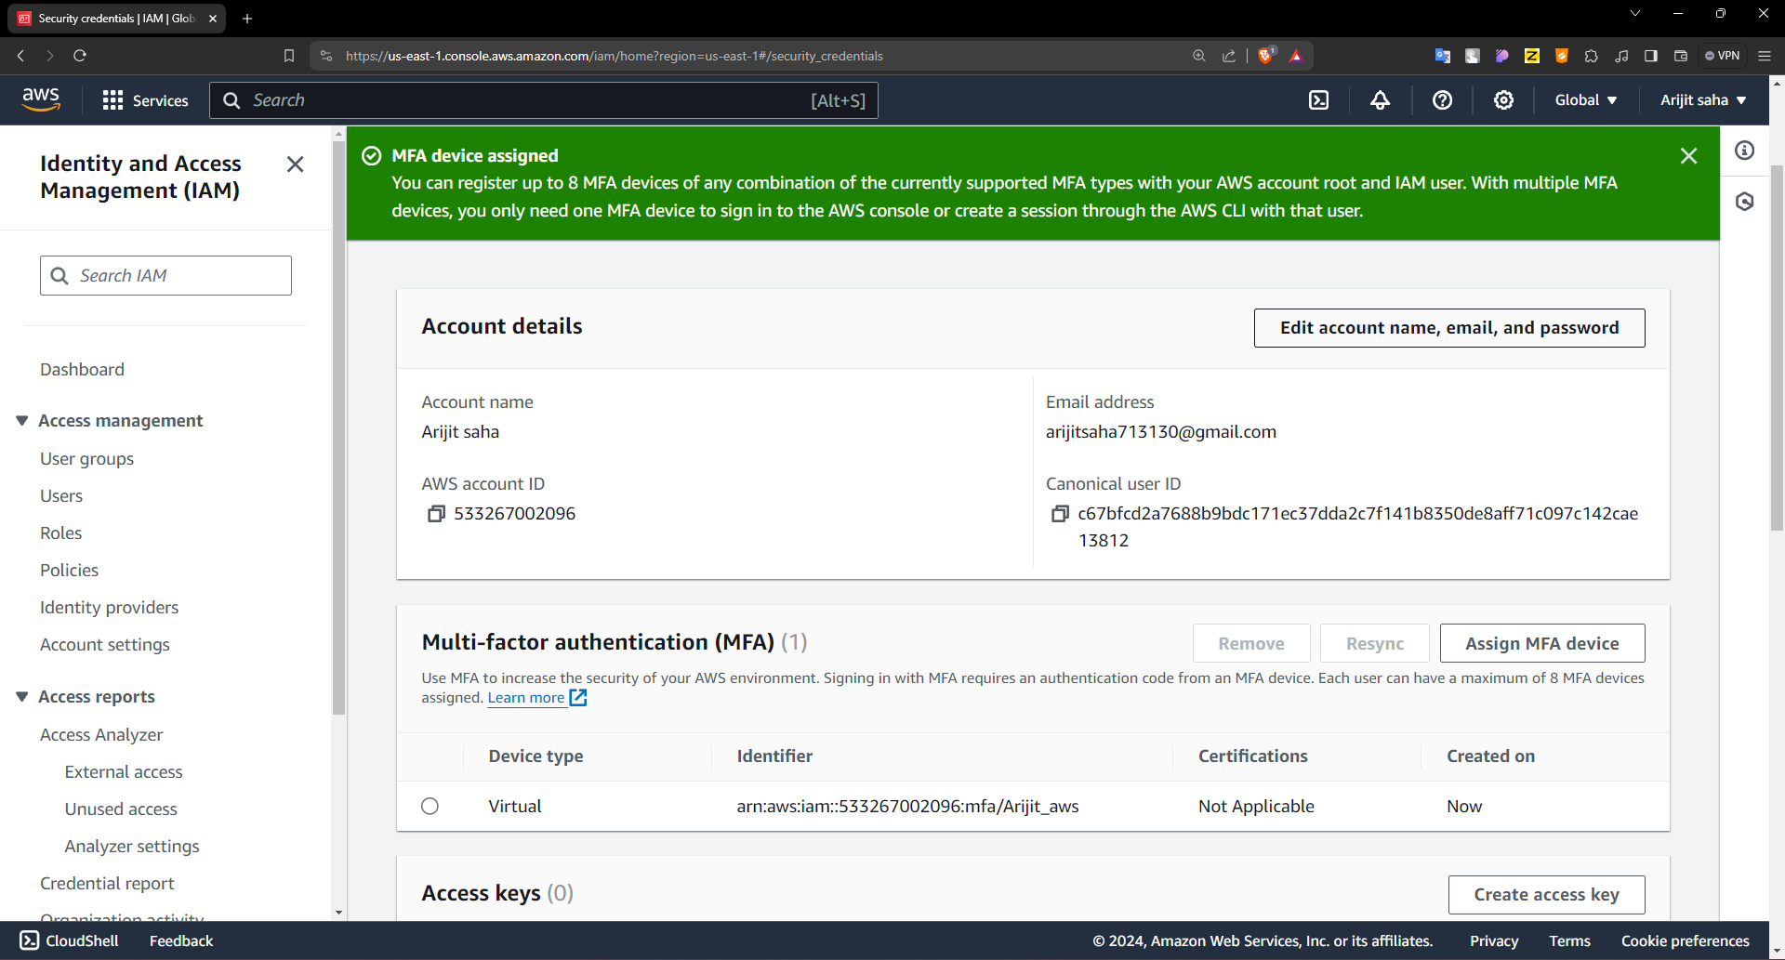

Supriyo Ghosh

supriyo_aws

Supriyoghosh27125@gmail.com